

What’s New in Room 202?

# Mrs. Hill

Mrs. Quinn’s Classroom Newsletter

# International Week

Every year Mrs. Hill, a previous parent from Emerson, comes in to teach the third graders the Sword Dance and the Cherry Blossom Dance. Mrs. Hill grew up in Japan so she is a wonderful person to share some of the Japanese culture with us! She stopped by yesterday for our first practice with the dances. We will be performing both dances at the end of the year during our tea ceremony! Mrs. Hill also volunteers each year to make hapi coats and kimonos for the third graders to wear during our different Japanese celebrations and activities that we will do. If you would like to purchase one for your child, she charges $15 for the hapi coat or kimono and you will need to purchase fabric for her to make it with. Mrs. Dalin and I have some hapi coats and kimonos for our classes to wear but not enough for everyone. Please check out Friday folders for additional information.

Each month I send home a scholastic catalogue in which you can order books. There are 2 ways to do this. You can fill out the back and send in a check (I’ll send this in for you) or you can do it online. Online is much easier and every time you place an online order, we get a free book for the classroom! I included the directions for online ordering with the August catalogue. If you plan to order anything from this months catalogue, the orders are due by August 30th.

November’s Scholastic Orders are due on November 22nd.

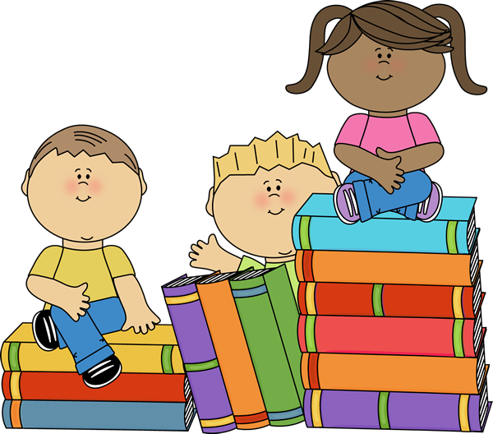

**Scholastic**

Next week is International Education week and we have a lot going on! We have started preparing this week by doing many activities about Japan. Our schedule for next week is:

**Monday:** Prepare for presenters and complete our passports.

**Tuesday:** Presenters in the morning.

**Wednesday:** Performance at the Church of the Messiah at 2:00

**Thursday:** Presenters in the morning

**Friday:** International Food Feast

Mrs. Quinn’s Classroom Newsletter Page 2

# The Weekly Review

## Upcoming Events

Laney and Corey are Advanced Readers!

Bella and Phillip are Independent Readers!



AR Awards

## Special Schedule

This week we…..

* Completed our rock experiments and switched to minerals.
* Worked on our Thanksgiving retellings.
* Read about Wolves in Time for Kids this week.
* Continued our reading groups to prepare for International Week.
* Worked on the distributive property with multiplication.

Monday: Music

Tuesday: PE

Wednesday: Library and Music

Thursday: Art

Friday: Computer Lab

11/18-International Week begins

11/22-Interims come home

11/25-Picture Retakes

11/27-11/29-No School